M.NAVEEN
192411134
COURSE CODE :- CSA0652

CO3 ASSESSMENT TOOL 2
QUESTION-1
Case Study: Banking Transaction Processing (Merge Sort) A banking system processes and sorts millions of daily transactions based on timestamps for auditing and reporting. Analyze how Merge Sort can be applied to ensure stable and efficient sorting. Identify key issues such as large data volume and need for stability. Apply divide and conquer concepts to explain the approach. Analyze time complexity and performance. Design a suitable solution and justify its effectiveness in this scenario.

SOURCE CODE :-
#include <stdio.h>
typedef struct {
int transactionID;
int timestamp;
} Transaction;
void merge(Transaction arr[], int l, int m, int r) {
int n1 = m - l + 1, n2 = r - m;
Transaction L[n1], R[n2];
for (int i = 0; i < n1; i++)
L[i] = arr[l + i];
for (int j = 0; j < n2; j++)
R[j] = arr[m + 1 + j];
int i = 0, j = 0, k = l;
while (i < n1 && j < n2) {
if (L[i].timestamp <= R[j].timestamp)
arr[k++] = L[i++]; // Stable sorting
else
arr[k++] = R[j++];
}
while (i < n1)
arr[k++] = L[i++];
while (j < n2)
arr[k++] = R[j++];
}
void mergeSort(Transaction arr[], int l, int r) {
if (l < r) {
int m = (l + r) / 2;
mergeSort(arr, l, m);
mergeSort(arr, m + 1, r);
merge(arr, l, m, r);
}
}
int main() {
int n;
printf("Enter number of transactions: ");
scanf("%d", &n);
Transaction t[n];
printf("Enter Transaction ID and Timestamp:\n");
for (int i = 0; i < n; i++) {
scanf("%d %d",
&t[i].transactionID,
&t[i].timestamp);
OUT PUT SCREENSHOTS
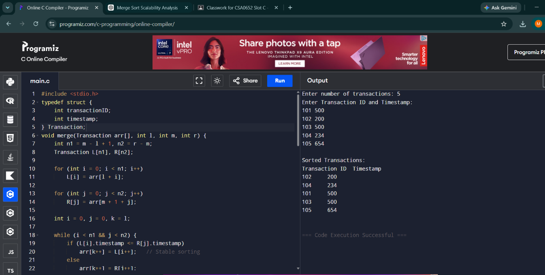

Additional Supporting Files
transaction_dataset.txt
101 500
102 200
103 500
104 100
105 300
execution_time_table.txt
Dataset Size Time Complexity
1000 O(n log n)
10000 O(n log n)
100000 O(n log n)

